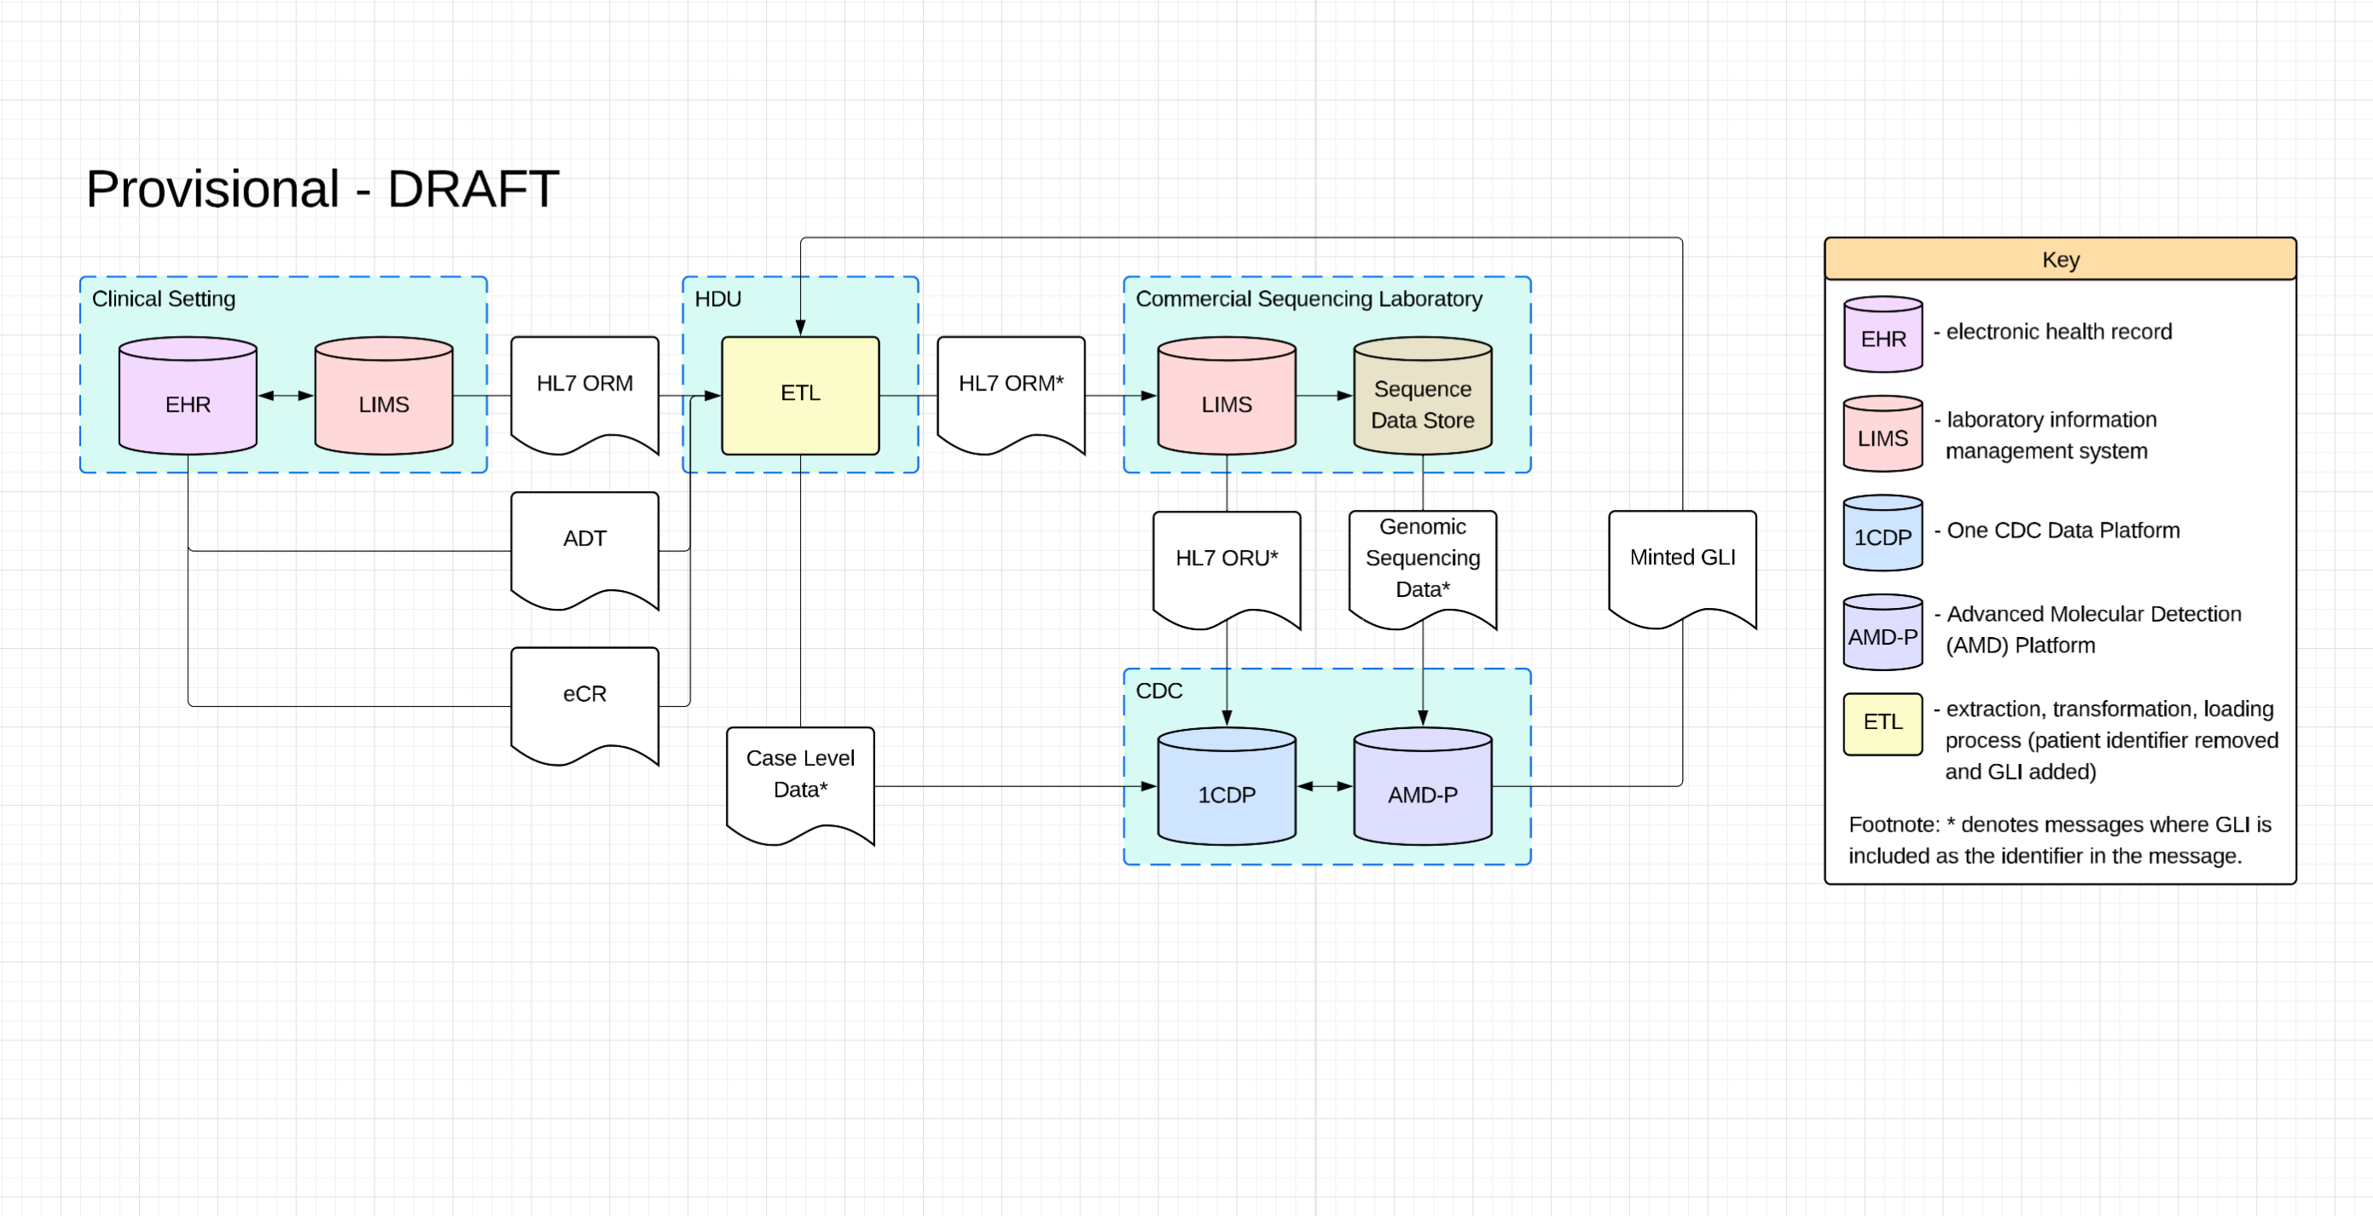

Biothreat Radar & Epidemic Intelligence Linkage Pilot
  - PHIG B4 Wave 3 Pilot Ideation, updated 05/20/2026

Bottom line up front
This pilot proves that a PHIG-funded Health Data Utility (HDU) or Health Information Exchange (HIE) can link BTR-funded genomic characterization results to the clinical event context it already holds and deliver fused, decision-ready situational awareness products to jurisdictions and CDC without manual reconciliation.
Two workstreams serve one objective: demonstrate HDU/HIE value for biothreat-related data linkage.
Workstream 1 (active, genomics linkage): The commercial sequencing laboratory receives a BTR-funded sequencing electronic laboratory order from a clinical setting via HDU typically using an HL7 v2.x message to request sequencing be performed. The HDU adds a pre-minted Genomic Linkage Identifier (GLI) to the electronic laboratory order. The GLI is minted by CDC’s Advanced Molecular Detection Platform (AMD-P), an enterprise pathogen genomic surveillance platform for CDC. Additionally, the HDU adds the GLI to additional case level data, with the same patient identifier as the electronic laboratory order, reported from the clinical setting to CDC. The GLI propagates through the commercial sequencing laboratory's pipeline; is submitted to the CDC alongside any data submissions including genomic sequencing data (e.g., FASTQ) and additional testing results; and can be matched by the CDC against the clinical context it already receives through existing encounter, laboratory, and syndromic feeds. BTR's contractual relationship with sequencing partners makes identifier propagation enforceable.
Workstream 2 (measurement, linkage key profiling): Across a broader set of HDUs/HIEs, profile the identifier landscape in existing clinical and laboratory feeds. Measure which linkage keys are present, how often, from which partners, and at what cross-stream match rates. This produces a national evidence base on HDU readiness for broader multi-stream linkage, a standalone PHIG data modernization deliverable that directly informs a future work in this space.

Why this matters
- HDUs/HIEs already receive the clinical side of the epidemic intelligence picture through PHIG-funded infrastructure: ADT encounter feeds, ORU laboratory results, syndromic surveillance data. We aim for HDUs to demonstrate the ability to link genomic characterization results back to that existing clinical context at scale, through commercial partners, using a standardized and repeatable pattern.
- The root cause is not that HDUs lack data. It is that no reliable identifier connects a genomic result arriving from a commercial sequencing laboratory to the clinical event the HDU already knows about. The chain from clinical encounter to final genomic sequence passes through multiple systems, each of which may accession the specimen under a different identifier. Linkage fails silently and manual reconciliation does not scale.

- BTR program funds sequencing through a commercial partner, it places an order. That order is the moment where a durable identifier can be injected before the specimen enters the laboratory's internal workflow and before re-accessioning fragments the identity chain.
- If needed, depending on what genomic data is submitted by the commercial partner, the AMD-P can scrub identifying human read data from the genomic data. This would only be required if the commercial partner is not de-hosting the genomic data they submit to the AMD-P. If unknown, the AMD-P can also pre-scan the data for any human reads as well.

Pilot purpose
PHIG value proposition: HDUs/HIEs demonstrate a new capability, automated linkage of BTR-funded genomic characterization to their existing clinical context, extending the public health value of PHIG-funded infrastructure. Jurisdictions gain fused situational awareness products without manual reconciliation.
Objectives:
- Demonstrate that a pre-minted GLI assigned at sequencing order placement propagates through a commercial pipeline and enables the HDU to link the genomic result to clinical event context it already holds.
- Define minimum contractual, technical, and operational requirements for GLI propagation across sequencing partnerships.
- Profile the linkage key landscape across HDU/HIE feeds to measure identifier availability and matchability in existing data streams, producing the evidence base for Phase 2.
- Produce measurable evidence on propagation success, breakage modes, latency, and decision utility with a clear path to scale.
- Adopt minimal sequencing information standards (ASqMi, MIxS; ASqMi and https://github.com/GenomicsStandardsConsortium/mixs) for genomic result content rather than bespoke schemas.

Scope and approach

Workstream 1: GLI-Based Genomics Linkage
2 to 3 HDUs/HIEs with operational clinical feeds and active BTR-funded sequencing engagements. The commercial sequencing laboratory receives a BTR-funded sequencing electronic laboratory order from a clinical setting via HDU typically using an HL7 v2.x message to request sequencing be performed. The HDU adds a pre-minted GLI to the electronic laboratory order. The GLI is minted by CDC’s AMD-P, an enterprise pathogen genomic surveillance platform for CDC. Additionally, the HDU adds the GLI to additional case level data, with the same patient identifier as the electronic laboratory order, reported from the clinical setting to CDC. The GLI propagates through the commercial sequencing laboratory's pipeline; is submitted to the CDC alongside any data submissions including genomic sequencing data (e.g., FASTQ) and additional testing results; and can be matched by the CDC against the clinical context it already receives through existing encounter, laboratory, and syndromic feeds.
Pilot jurisdictions are selected based on having a BTR sequencing engagement with a commercial partner that will accept GLI propagation as a contractual condition. Pilot jurisdictions can retrieve GLIs, NCBI accession identifiers, and sequence data from AMD-P.

Workstream 2: Linkage Key Profiling
5 to 6 HDUs/HIEs selected for diversity of commercial laboratory partners and LIMS platforms. Profile existing ADT, ORU, ELR, and syndromic feeds for population rates of visit numbers (PV1-19), placer order numbers (ORC-2/OBR-2), filler order numbers (ORC-3/OBR-3), and specimen IDs (SPM-2). Attempt cross-stream matching to measure actual linkage potential. No new data flows, no intervention. Timeline: 2 to 3 months onboarding, 3 to 4 months profiling, remainder for analysis.

GLI Specification
The GLI is a globally unique, jurisdiction-neutral identifier minted by the AMD-P at sequencing order placement. Structure: HDU namespace + sequencing partner code + order-unique component. Machine-readable, non-guessable, no embedded PHI.
The commercial sequencing laboratory carries the GLI through its internal pipeline and includes it in the outbound result. The laboratory keeps its own accession numbers; the GLI travels alongside as an external identifier. HL7 v2 mapping: SPM-2 or OBR-3. FHIR mapping: Specimen.identifier or DiagnosticReport.identifier. Field selection defined per partner laboratory during onboarding.
Event metadata captured at GLI registration: ordering jurisdiction, facility NPI, specimen collection date, specimen type, clinical indication, patient jurisdiction FIPS code. No direct patient identifiers in the registry.
Where a single specimen generates multiple tests or sequencing runs, all downstream results reference the same GLI. The registry models the one-to-many relationship explicitly.

Data streams and exchange mechanisms
- Already operational at the HDU (not built for this pilot): HL7 v2.5.1 ADT feeds, ORU laboratory results, syndromic surveillance, FHIR clinical enrichment aligned to US Core and USCDI v3.
- New for this pilot: Sequencing orders carrying the GLI (outbound to commercial laboratories), and genomic results carrying the GLI (inbound from commercial laboratories). Genomic result content follows a minimal sequence information standard aligned to ASqMi/MIxS covering organism identification (NCBI Taxonomy), lineage (PANGO or equivalent), variant calls, resistance markers, quality metrics, sequencing method, and pipeline version.
- Terminology governance: Reference PANGO lineage nomenclature, MLST schema registries, and NCBI Taxonomy. Do not create bespoke code systems. Align value sets using HL7 Unified Terminology Governance.

Standards and trust layer

Standards baseline: US Core and USCDI v3 for clinical elements. Minimal sequence information standard for genomic results. HL7 Genomics Reporting IG v3.0.0 as a post-pilot formalization target.
Trust scoring (Workstream 1): In-motion: GLI present and registry-matched, payload conformance to minimal sequence information standard, result timestamp within genomics SLA. At-rest: propagation success rate, breakage by reason code and partner laboratory, latency distributions, field completeness.
Trust scoring (Workstream 2): Linkage key population rates by field, sending laboratory, and jurisdiction. Cross-stream match rates. Identifier formatting consistency.
Genomics latency: 3 to 10 days from specimen receipt to quality-controlled sequence, defined per partner laboratory. Dashboards degrade gracefully when genomic context is pending, showing data-freshness and linkage status indicators.
Minimum data necessary: Role-based access, auditable handling. Registry access restricted to HDU and originating jurisdiction. CDC/BTR receives linked products, not raw registry data.

Deliverables
- GLI Acquisition: Establish connectivity to AMD-P GLI registry for acquisition of GLIs to be used by HDU.
- Minimal sequence information standard: Pilot-defined metadata schema aligned to ASqMi/MIxS, with validation rules operated by the HDU.
- HDU operational specifications: Result-matching logic, clinical context fusion procedures, audit logging requirements. Sized for lookup-and-match within current HDU capability.
- Linkage key profiling report (Workstream 2): Population rates, cross-stream match rates, identifier quality findings across HDUs/HIEs. Evidence-based recommendations for Phase 2 linkage architecture. Independently valuable as a PHIG data modernization output.
- Decision-ready products: Baseline monitoring view, anomaly awareness view, and event characterization view with linkage status and data-freshness indicators. Graceful degradation when genomics context is pending.
- Trust scorecards: GLI propagation rates, linkage key population rates, breakage analysis, latency distributions. Published weekly.
- Scale playbook: Onboarding procedures for additional HDUs/HIEs and sequencing partners using the same GLI specification and profiling methodology.
- Phase 2 roadmap: Evidence-based recommendations for extending linkage to broader streams, informed by both workstreams. Maps where pre-minted identifiers can extend, where existing keys are viable, and where probabilistic matching is needed.

Evaluation and success measures
Workstream 1
- GLI propagation rate: Target 80% or above by end of pilot. Justified by contractual enforceability. Reason-coded breakage for the remainder.
- HDU clinical context fusion rate: Of GLI-linked results, what percentage matched to existing encounter or laboratory records in HDU feeds.
- End-to-end latency: Order to specimen receipt, specimen receipt to QC'd result, result receipt to linked product. Reported separately.
- Decision utility: Structured feedback from jurisdiction epidemiologists and BTR analysts on whether linked products improve situational awareness compared to unlinked genomic results.
Workstream 2
- Identifier availability baseline: Population rates for each linkage key across all profiled feeds, segmented by sending laboratory, message type, and jurisdiction.
- Cross-stream match rate: Percentage of laboratory results with identifiers that successfully match encounter records in the same HDU's feeds.
Cross-cutting
- Onboarding effort: Time and resources per HDU/HIE and per sequencing partner. Directly measures scalability.

Partner roles
HDUs/HIEs: Central pilot actor. Fuse genomic results with existing clinical context, produce linked products, run trust scoring, profile existing feeds (Workstream 2). Demonstrate new PHIG-funded capability.
Jurisdictions: Place or authorize sequencing orders with complete metadata. Receive and validate linked products for local response. Provide structured feedback on decision utility.
Commercial sequencing partner laboratories: Accept GLI on inbound orders, carry through pipeline, include in outbound results. Collaborate on LIMS configuration during onboarding.
CDC/BTR: Define acceptance criteria, align outputs to BTR operational questions, evaluate findings for future sequencing partner requirements and national identifier policy. AMD-P to Mint GLIs and operate GLI registry.

Governance
- No patient identifiers in the GLI registry, so no person-level DUAs required for core linkage. HDU existing feeds operate under existing authorization. Registry access restricted to HDU and originating jurisdiction with audit logging. GLI propagation is a contractual obligation in sequencing agreements. Workstream 2 profiling produces aggregate statistics, not individual records.
- To resolve during onboarding: Jurisdiction-laboratory pair mapping and ordering workflow documentation. HDU operating agreement covering registry SLAs, security controls, and audit requirements. Reporting relationship authority for genomic result flows through the HDU. Phase 2 authorization planning for person-level matching (begin mapping DUA pathways during pilot to avoid cold-start in Phase 2).

